Data Mining Assignment 2

1) Read Chapter 1 (all) and Chapter 2 (only sections 2.1, 2.2 and 2.3).  
  
2) Redo In Class Exercises #1 and #2, but use different examples from those which we used in class.  
  
3) Do Chapter 2 textbook [problem #2](http://www.cob.sjsu.edu/mease_d/bus297D/ch2textbookquestion.doc) on page 89.

Classify the following attributes as binary, discrete, or continuous. Also classify them as qualitative (nominal or ordinal) or quantitative (interval or ratio). Some cases may have more than one interpretation, so briefly indicate your reasoning if you think there may be some ambiguity.

Example: Age in years. Answer: Discrete, quantitative, ratio

a) Time in terms of AM or PM.

* Binary, qualitative, nominal

b) Brightness as measured by a light meter.

* Continuous, quantitative, ratio

c) Brightness as measured by people's judgments.

* Discrete, qualitative, ordinal

d) Angles as measured in degrees between 0 and 360.

* Continuous, quantitative, ratio

e) Bronze, Silver, and Gold medals as awarded at the Olympics.

* Discrete, qualitative, ordinal

f) Height above sea level.

* Continuous, quantitative, interval/ratio

g) Number of patients in a hospital.

* Discrete, quantitative, ratio

h) ISBN numbers for books. (Look up the format on the Web.)

* Discrete, qualitative, nominal

i) Ability to pass light in terms of the following values: opaque, translucent, transparent.

* Discrete, qualitative, ordinal

j) Military rank.

* Discrete, qualitative, ordinal

k) Distance from the centre of campus.

* Continuous, quantitative, ratio

l) Density of a substance in grams per cubic centimetre.

* Continuous, quantitative, ratio

m) Coat check number. (When you attend an event, you can often give your coat to someone who, in turn, gives you a number that you can use to claim your coat when you leave.)

* Discrete, qualitative, nominal

4) This question uses the data at <http://www.cob.sjsu.edu/mease_d/bus297D/myfirstdata.csv>. Download it to your computer.  
  
a) Read in the data in R using data←read.csv("myfirstdata.csv",header=FALSE).

Note, you first need to specify your working directory using the setwd() command. Determine whether each of the two attributes (columns) is treated as qualitative (categorical) or quantitative (numeric) using R. Explain how you can tell using R.

|  |
| --- |
|  |
| * The first attribute is treated as quantitative value because its attribute type is integer. * The second is treated as qualitative value because its attribute type is character. |
|  |

b) What is the specific problem that causes one of these two attributes to be read in as qualitative (categorical) when it seems it should be quantitative (numeric)?

* As we can see from the results above, V2 is “0”, "3", etc which are strings. The V2 column is character.
* some of the values in column V2 contain characters, that's why it read as categorical.

c) Use the command plot() in R to make a plot for each column by entering plot(data[,1]) and plot(data[,2]). Because one variable is read in as quantitative (numeric) and the other as qualitative (categorical) these two plots are showing completely different things by default. Explain exactly what is being plotted in each of the two cases. Include these two plots in your homework.

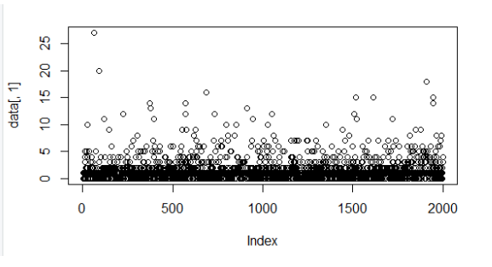

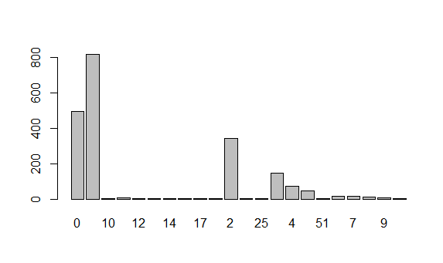

* Column V1 is numeric data, it shows the distribution of the numbers of the integer from 0 to 2000
* Although Column V2 is categorical data, it shows the distribution of the numbers of the categorical data from 0 to 2000

d) Read the data into Excel. Excel should have no problem opening the file directly since it is .csv. Create a new column that is equal to the second column plus 10. What is the result for the problem observations (rows) you identified in part b? What specific outcome does Excel display?

* As we previously saw, there is a non-numeric value present in the 1463 line. So we get an undefined error, for a reason because we are trying to add string ‘two’ which is in the second column and number 10 which is not possible.

5) This question uses the data at <http://www.cob.sjsu.edu/mease_d/bus297D/twomillion.csv>. Download it to your computer.  
  
a) Read the data into R using data<-read.csv("twomillion.csv",header=FALSE). Note, you first need to specify your working directory using the setwd() command. Extract a simple random sample with replacement of 10,000 observations (rows). Show your R commands for doing this.

setwd("C:/Users/Shravya/OneDrive/Desktop/DataScience_2019501095/DataMining/DM Assignment2")

getwd()

data<-read.csv("twomillion.csv",header=FALSE)

sampledata<-sample(data[,1],10000,replace=TRUE)

b) For your sample, use the functions mean(), max(), var() and quantile(,.25) to compute the mean, maximum, variance and 1st quartile respectively. Show your R code and the resulting values.

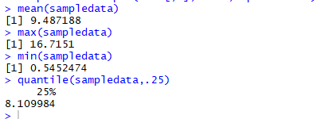

c) Compute the same quantities in part b on the entire data set and show your answers. How much do they differ from your answers in part b?

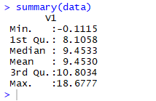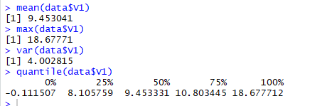  
  
d) Save your sample from R to a csv file using the command write.csv(). Then open this file with Excel and compute the mean, maximum, variance and 1st quartile. Provide the values and name the Excel functions you used to compute these.

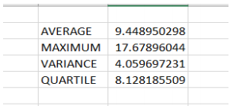  
  
e) Exactly what happens if you try to open the full data set with Excel?

* It displays total of 1048576 rows

6) Read Chapter 3 (only sections 3.1, 3.2 and 3.3).  
  
7) This question uses a sample of 1500 California house prices at <http://www-stat.wharton.upenn.edu/~dmease/CA_house_prices.csv> and a sample of 10,000 Ohio house prices at <http://www-stat.wharton.upenn.edu/~dmease/OH_house_prices.csv>. Download both data sets to your computer. Note that the house prices are in thousands of dollars.  
  
a) Use R to produce a single graph displaying a boxplot for each set (as in ICE #16). Include the R commands and the plot. Put your name in the title of the plot (for example, main="Britney Spears' Boxplots").

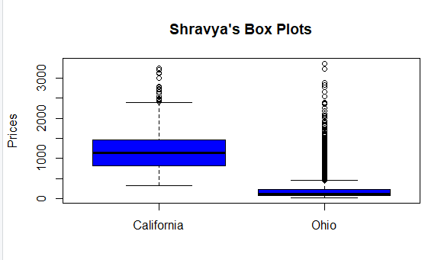  
  
b) Use R to produce a frequency histogram for only the California house prices. Use intervals of width $500,000 beginning at 0 and ending at $3.5 million. Include the R commands and the plot. Put your name in the title of the plot.

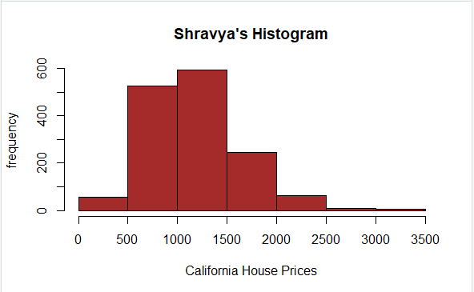  
  
c) Use R to plot the ECDF of the California houses and Ohio houses on the same graph (as in ICE #11). Include a legend. Include the R commands and the plot. Put your name in the title of the plot.

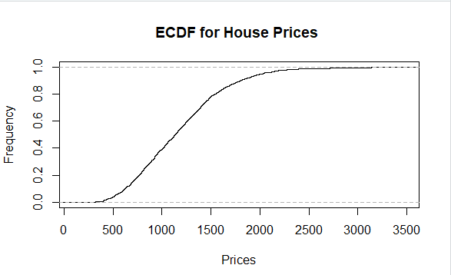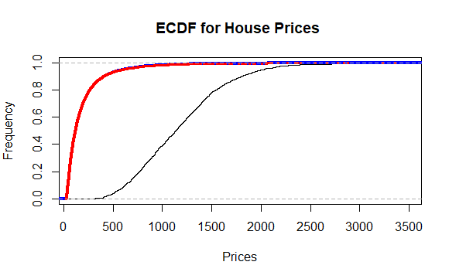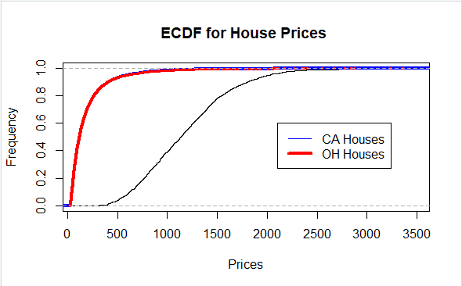  
  
8) This question uses the data at <http://www-stat.wharton.upenn.edu/~dmease/football.csv>. Download it to your computer. This data set gives the total number of wins for each of the 117 Division 1A college football teams for the 2003 and 2004 seasons.   
  
a) Use plot() in R to make a scatter plot for this data with 2003 wins on the x-axis and 2004 wins on the y-axis. Use the range 0 to 12 for both the x-axis and y-axis. Include the R commands and the plot. Put your name in the title of the plot.

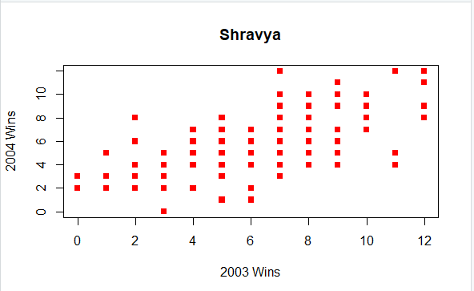  
  
b) Why are there fewer than 117 points visible on your graph in part a? Describe the solution we discussed in class to deal with this problem (but don't actually do it).

* There are some data which are plotted on the same set of axes and are not visible because they were plotted on top of each other, The solution is to add a small amount of noise to the points which we have plotted in the graph.

c) Compute the correlation in R using the function cor().

  
  
d) How does the value in part c change if you add 10 to all the values for 2004?



No change in value  
  
e) How does the value in part c change if you multiply all the 2004 values by 2?



No change in value  
  
f) How does the value in part c change if you multiply all the 2004 values by -2?



The value became negative  
  
9) This question uses the sample of 10,000 Ohio house prices at <http://www-stat.wharton.upenn.edu/~dmease/OH_house_prices.csv>. Download the data set to your computer. Note that the house prices are in thousands of dollars.  
  
a) What is the median value? Is it larger or smaller than the mean?

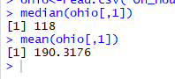

Median is smaller than mean  
  
b) What does your answer to part a suggest about the shape of the distribution (right-skewed or left-skewed)?

* The mean is greater than median so the data is right skewed.

c) How does the median change if you add 10 (thousand dollars) to all the values?



Value of median increases by 10  
  
d) How does the median change if you multiply all the values by 2?



Value of median becomes double  
  
10) This question uses the following people's ages: 19,23,30,30,45,25,24,20. Store them in R using the syntax ages<-c(19,23,30,30,45,25,24,20).  
  
a) Compute the standard deviation in R using the sd() function.

  
  
b) Compute the same value by hand and show all the steps.

* Mean: (19 + 23 + 30 + 30 + 45 + 25 + 24 + 20) / 8 = 216 / 8 = 27
* Deviations: -8, -4, 3, 3, 18, -2, -3, -7
* Squares of deviations: 64, 16, 9, 9, 324, 4, 9, 49
* Sum of deviations: 64 + 16 + 9 + 9 + 324 + 4 + 9 + 49 = 484
* Divided by one less than the number of items in the list: 484 / 7 = 69.14285
* Square root: square root (69.14285) = approx. 8.31521

c) Using R, how does the value in part a change if you add 10 to all the values?



No change in value

d) Using R, how does the value in part a change if you multiply all the values by 100?



Value is 10 times greater than the original value